Rep

**PROJECT ON GAME**

**LIBERARY’S USED IN THIS CODE**

* Import java.util.Random;
* Import java.util.Scanner;
* **Import java.util.Random** is used to generate random numbers or letters in a series or column.
* **Import java.util.Scanner library** is used to take input from a user.

**PROJECT DONE BY:**

**MASHOOQUE ALI MASHORI**

**SUMAIR ALI**

**CONDITIONS USED IN THIS PROJECT**

* Arrays
* For loop
* If else condition

**Arrays:** An Array is a collection of similar data elements stored at contiguous memory locations.

**LOOP:** Loops are used to repeat a block of code.

**IF ELSE CONDITION:** Use if to specify a block of code to be executed, if a specified code is true. Use else if same code is false.

**PROJECT DONE BY:**

**MASHOOQUE ALI MASHORI**

**SUMAIR ALI**

**WORKING OF CODE**

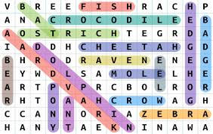

This Project is on **Game** in which you have to

Input collection of characters that input checked Horizently if it found Horizently then show message that it found horizontally if it not then show not found it also check Vertically if it found vertically then show message that found vertically if it not found vertically then show message that not found vertically, it check diagonally if it found diagonally then show message that found diagonally if it not found diagonally then show message that not found diagonally.

THANK YOU

**PROJECT DONE BY:**

**MASHOOQUE ALI MASHORI**

**SUMAIR ALI**